Calculating Maintainability Index

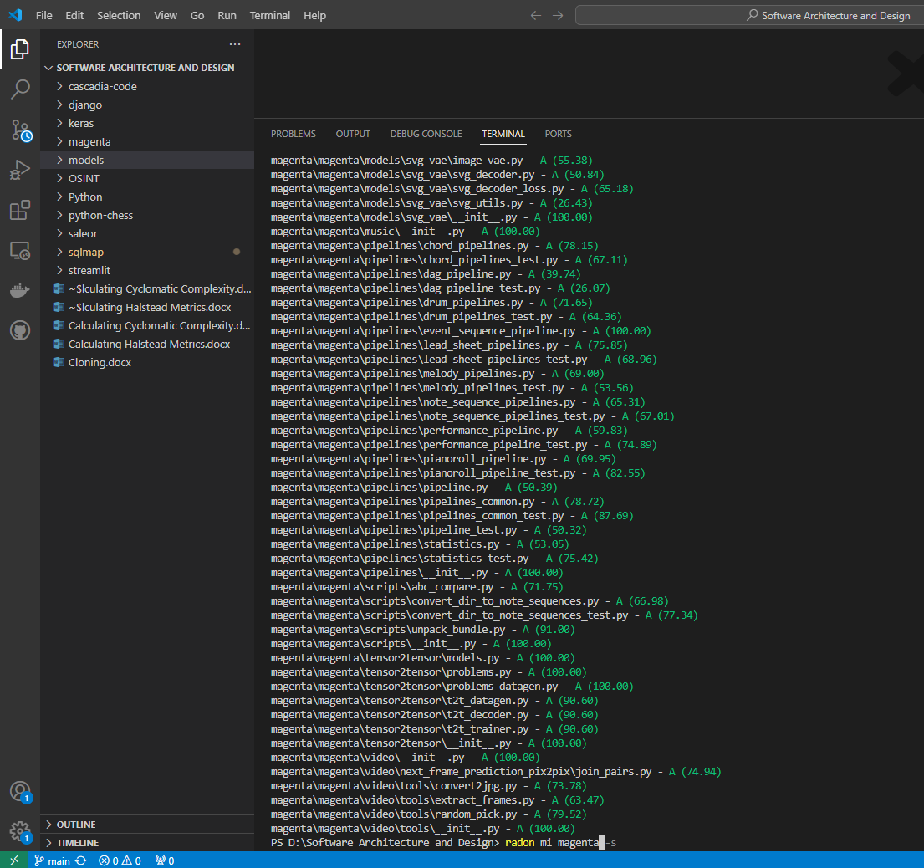

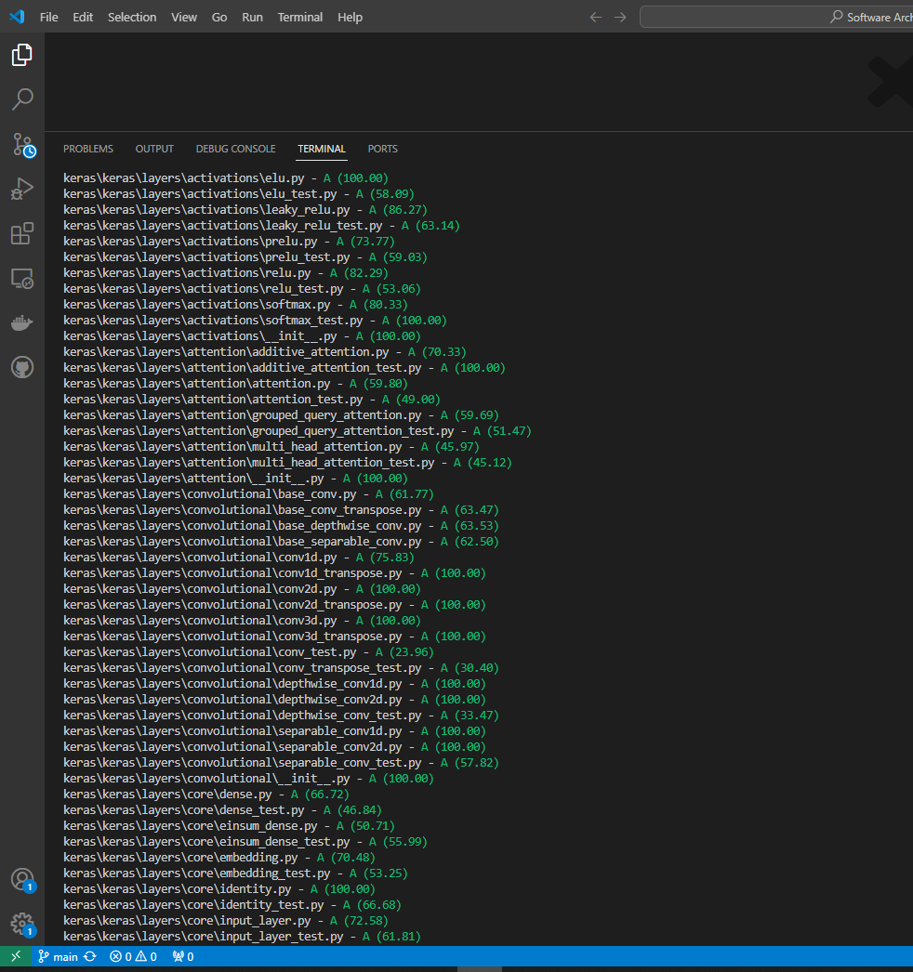

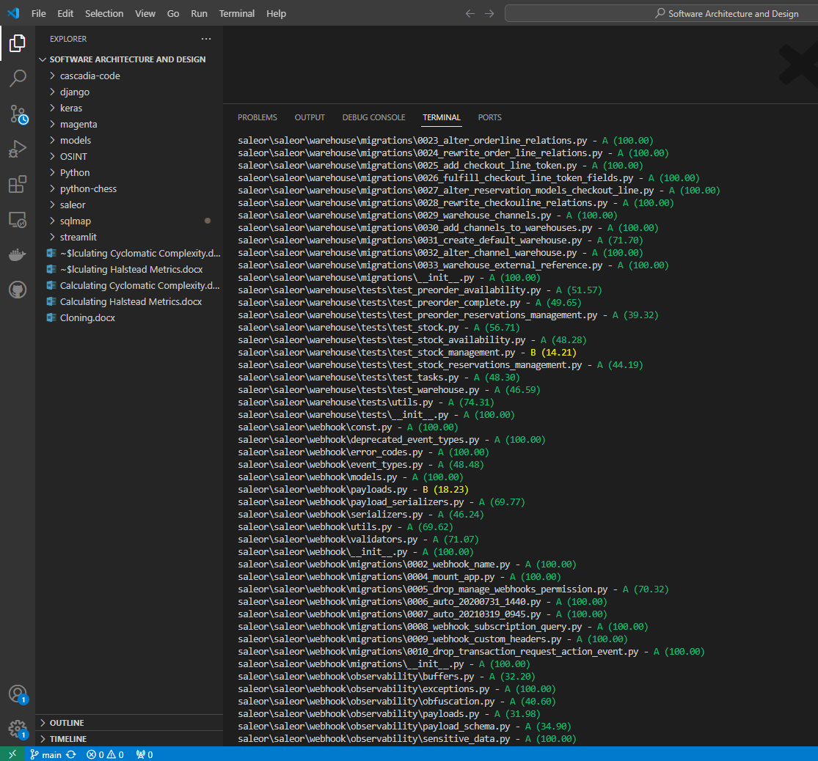

PS D:\Software Architecture and Design> radon mi sqlmap -s

sqlmap\sqlmap.py - B (9.14)

sqlmap\sqlmapapi.py - A (65.07)

sqlmap\extra\__init__.py - A (100.00)

sqlmap\extra\beep\beep.py - A (62.17)

sqlmap\extra\beep\__init__.py - A (100.00)

sqlmap\extra\cloak\cloak.py - A (60.59)

sqlmap\extra\cloak\__init__.py - A (100.00)

sqlmap\extra\dbgtool\dbgtool.py - A (58.32)

sqlmap\extra\dbgtool\__init__.py - A (100.00)

sqlmap\extra\icmpsh\icmpsh_m.py - A (69.33)

sqlmap\extra\icmpsh\__init__.py - A (100.00)

sqlmap\extra\shutils\duplicates.py - A (84.77)

sqlmap\extra\shutils\newlines.py - A (67.99)

sqlmap\extra\vulnserver\vulnserver.py - A (33.14)

sqlmap\extra\vulnserver\__init__.py - A (100.00)

sqlmap\lib\__init__.py - A (100.00)

sqlmap\lib\controller\action.py - A (42.70)

sqlmap\lib\controller\checks.py - C (0.00)

sqlmap\lib\controller\controller.py - C (0.00)

sqlmap\lib\controller\handler.py - A (48.28)

sqlmap\lib\controller\__init__.py - A (100.00)

sqlmap\lib\core\agent.py - C (0.00)

sqlmap\lib\core\bigarray.py - A (48.00)

sqlmap\lib\core\common.py - C (0.00)

sqlmap\lib\core\compat.py - A (52.61)

sqlmap\lib\core\convert.py - A (42.31)

sqlmap\lib\core\data.py - A (100.00)

sqlmap\lib\core\datatype.py - A (56.43)

sqlmap\lib\core\decorators.py - A (81.26)

sqlmap\lib\core\defaults.py - A (100.00)

sqlmap\lib\core\dicts.py - A (57.82)

sqlmap\lib\core\dump.py - C (0.00)

sqlmap\lib\core\enums.py - A (41.75)

sqlmap\lib\core\exception.py - A (100.00)

sqlmap\lib\core\gui.py - A (41.52)

sqlmap\lib\core\log.py - A (53.51)

sqlmap\lib\core\option.py - C (0.00)

sqlmap\lib\core\optiondict.py - A (100.00)

sqlmap\lib\core\patch.py - A (58.24)

sqlmap\lib\core\profiling.py - A (94.77)

sqlmap\lib\core\readlineng.py - A (77.14)

sqlmap\lib\core\replication.py - A (66.80)

sqlmap\lib\core\revision.py - A (73.78)

sqlmap\lib\core\session.py - A (75.95)

sqlmap\lib\core\settings.py - A (47.52)

sqlmap\lib\core\shell.py - A (56.87)

sqlmap\lib\core\subprocessng.py - A (41.99)

sqlmap\lib\core\target.py - C (2.10)

sqlmap\lib\core\testing.py - A (35.89)

sqlmap\lib\core\threads.py - A (42.19)

sqlmap\lib\core\unescaper.py - A (83.92)

sqlmap\lib\core\update.py - A (40.40)

sqlmap\lib\core\wordlist.py - A (63.69)

sqlmap\lib\core\__init__.py - A (100.00)

sqlmap\lib\parse\banner.py - A (60.65)

sqlmap\lib\parse\cmdline.py - B (14.13)

sqlmap\lib\parse\configfile.py - A (64.28)

sqlmap\lib\parse\handler.py - A (65.99)

sqlmap\lib\parse\headers.py - A (94.43)

sqlmap\lib\parse\html.py - A (69.77)

sqlmap\lib\parse\payloads.py - A (62.95)

sqlmap\lib\parse\sitemap.py - A (67.80)

sqlmap\lib\parse\__init__.py - A (100.00)

sqlmap\lib\request\basic.py - A (24.44)

sqlmap\lib\request\basicauthhandler.py - A (89.50)

sqlmap\lib\request\chunkedhandler.py - A (81.37)

sqlmap\lib\request\comparison.py - A (42.52)

sqlmap\lib\request\connect.py - C (0.00)

sqlmap\lib\request\direct.py - A (53.42)

sqlmap\lib\request\dns.py - A (56.77)

sqlmap\lib\request\httpshandler.py - A (57.96)

sqlmap\lib\request\inject.py - B (9.91)

sqlmap\lib\request\methodrequest.py - A (100.00)

sqlmap\lib\request\pkihandler.py - A (90.31)

sqlmap\lib\request\rangehandler.py - A (96.63)

sqlmap\lib\request\redirecthandler.py - A (38.77)

sqlmap\lib\request\templates.py - A (95.63)

sqlmap\lib\request\__init__.py - A (100.00)

sqlmap\lib\takeover\abstraction.py - A (38.21)

sqlmap\lib\takeover\icmpsh.py - A (50.33)

sqlmap\lib\takeover\metasploit.py - B (9.26)

sqlmap\lib\takeover\registry.py - A (56.74)

sqlmap\lib\takeover\udf.py - A (20.65)

sqlmap\lib\takeover\web.py - A (24.79)

sqlmap\lib\takeover\xp_cmdshell.py - A (39.02)

sqlmap\lib\takeover\__init__.py - A (100.00)

sqlmap\lib\techniques\__init__.py - A (100.00)

sqlmap\lib\techniques\blind\inference.py - B (13.96)

sqlmap\lib\techniques\blind\__init__.py - A (100.00)

sqlmap\lib\techniques\dns\test.py - A (81.86)

sqlmap\lib\techniques\dns\use.py - A (53.83)

sqlmap\lib\techniques\dns\__init__.py - A (100.00)

sqlmap\lib\techniques\error\use.py - B (16.25)

sqlmap\lib\techniques\error\__init__.py - A (100.00)

sqlmap\lib\techniques\union\test.py - A (26.62)

sqlmap\lib\techniques\union\use.py - A (22.62)

sqlmap\lib\techniques\union\__init__.py - A (100.00)

sqlmap\lib\utils\api.py - B (11.95)

sqlmap\lib\utils\brute.py - A (21.35)

sqlmap\lib\utils\crawler.py - A (33.67)

sqlmap\lib\utils\deps.py - A (41.74)

sqlmap\lib\utils\getch.py - A (82.81)

sqlmap\lib\utils\har.py - A (44.37)

sqlmap\lib\utils\hash.py - C (0.00)

sqlmap\lib\utils\hashdb.py - A (36.05)

sqlmap\lib\utils\httpd.py - A (47.12)

sqlmap\lib\utils\pivotdumptable.py - A (37.10)

sqlmap\lib\utils\progress.py - A (66.48)

sqlmap\lib\utils\purge.py - A (65.02)

sqlmap\lib\utils\safe2bin.py - A (71.36)

sqlmap\lib\utils\search.py - A (42.75)

sqlmap\lib\utils\sgmllib.py - A (25.00)

sqlmap\lib\utils\sqlalchemy.py - A (48.36)

sqlmap\lib\utils\timeout.py - A (84.24)

sqlmap\lib\utils\versioncheck.py - A (85.32)

sqlmap\lib\utils\xrange.py - A (69.19)

sqlmap\lib\utils\__init__.py - A (100.00)

sqlmap\plugins\__init__.py - A (100.00)

sqlmap\plugins\dbms\__init__.py - A (100.00)

sqlmap\plugins\dbms\access\connector.py - A (75.61)

sqlmap\plugins\dbms\access\enumeration.py - A (100.00)

sqlmap\plugins\dbms\access\filesystem.py - A (100.00)

sqlmap\plugins\dbms\access\fingerprint.py - A (44.35)

sqlmap\plugins\dbms\access\syntax.py - A (96.85)

sqlmap\plugins\dbms\access\takeover.py - A (90.30)

sqlmap\plugins\dbms\access\__init__.py - A (100.00)

sqlmap\plugins\dbms\altibase\connector.py - A (100.00)

sqlmap\plugins\dbms\altibase\enumeration.py - A (100.00)

sqlmap\plugins\dbms\altibase\filesystem.py - A (100.00)

sqlmap\plugins\dbms\altibase\fingerprint.py - A (59.20)

sqlmap\plugins\dbms\altibase\syntax.py - A (96.85)

sqlmap\plugins\dbms\altibase\takeover.py - A (90.30)

sqlmap\plugins\dbms\altibase\__init__.py - A (100.00)

sqlmap\plugins\dbms\cache\connector.py - A (74.39)

sqlmap\plugins\dbms\cache\enumeration.py - A (100.00)

sqlmap\plugins\dbms\cache\filesystem.py - A (100.00)

sqlmap\plugins\dbms\cache\fingerprint.py - A (52.88)

sqlmap\plugins\dbms\cache\syntax.py - A (94.65)

sqlmap\plugins\dbms\cache\takeover.py - A (90.30)

sqlmap\plugins\dbms\cache\__init__.py - A (100.00)

sqlmap\plugins\dbms\clickhouse\connector.py - A (100.00)

sqlmap\plugins\dbms\clickhouse\enumeration.py - A (100.00)

sqlmap\plugins\dbms\clickhouse\filesystem.py - A (100.00)

sqlmap\plugins\dbms\clickhouse\fingerprint.py - A (57.86)

sqlmap\plugins\dbms\clickhouse\syntax.py - A (96.85)

sqlmap\plugins\dbms\clickhouse\takeover.py - A (90.30)

sqlmap\plugins\dbms\clickhouse\__init__.py - A (100.00)

sqlmap\plugins\dbms\cratedb\connector.py - A (84.28)

sqlmap\plugins\dbms\cratedb\enumeration.py - A (100.00)

sqlmap\plugins\dbms\cratedb\filesystem.py - A (100.00)

sqlmap\plugins\dbms\cratedb\fingerprint.py - A (57.86)

sqlmap\plugins\dbms\cratedb\syntax.py - A (100.00)

sqlmap\plugins\dbms\cratedb\takeover.py - A (90.30)

sqlmap\plugins\dbms\cratedb\__init__.py - A (100.00)

sqlmap\plugins\dbms\cubrid\connector.py - A (82.55)

sqlmap\plugins\dbms\cubrid\enumeration.py - A (100.00)

sqlmap\plugins\dbms\cubrid\filesystem.py - A (100.00)

sqlmap\plugins\dbms\cubrid\fingerprint.py - A (57.86)

sqlmap\plugins\dbms\cubrid\syntax.py - A (94.65)

sqlmap\plugins\dbms\cubrid\takeover.py - A (90.30)

sqlmap\plugins\dbms\cubrid\__init__.py - A (100.00)

sqlmap\plugins\dbms\db2\connector.py - A (80.30)

sqlmap\plugins\dbms\db2\enumeration.py - A (100.00)

PS D:\Software Architecture and Design> radon mi saleor -s

saleor\conftest.py - A (77.42)

saleor\manage.py - A (99.90)

saleor\saleor\celeryconf.py - A (100.00)

saleor\saleor\settings.py - A (42.87)

saleor\saleor\urls.py - A (67.78)

saleor\saleor\__init__.py - A (100.00)

saleor\saleor\__main__.py - A (100.00)

saleor\saleor\account\app.py - A (100.00)

saleor\saleor\account\error_codes.py - A (100.00)

saleor\saleor\account\events.py - A (100.00)

saleor\saleor\account\forms.py - A (58.74)

saleor\saleor\account\i18n.py - A (40.47)

saleor\saleor\account\models.py - A (44.15)

saleor\saleor\account\notifications.py - A (60.18)

saleor\saleor\account\search.py - A (59.07)

saleor\saleor\account\signals.py - A (100.00)

saleor\saleor\account\utils.py - A (54.55)

saleor\saleor\account\validators.py - A (68.14)

saleor\saleor\account\widgets.py - A (100.00)

saleor\saleor\account\__init__.py - A (100.00)

saleor\saleor\account\management\__init__.py - A (100.00)

saleor\saleor\account\management\commands\changepassword.py - A (100.00)

saleor\saleor\account\management\commands\createsuperuser.py - A (38.94)

saleor\saleor\account\management\commands\__init__.py - A (100.00)

saleor\saleor\account\migrations\0001_initial.py - A (100.00)

saleor\saleor\account\migrations\0002_auto_20150907_0602.py - A (100.00)

saleor\saleor\account\migrations\0003_auto_20151104_1102.py - A (100.00)

saleor\saleor\account\migrations\0004_auto_20160114_0419.py - A (100.00)

saleor\saleor\account\migrations\0005_auto_20160205_0651.py - A (100.00)

saleor\saleor\account\migrations\0006_auto_20160829_0819.py - A (100.00)

saleor\saleor\account\migrations\0007_auto_20161115_0940.py - A (100.00)

saleor\saleor\account\migrations\0008_auto_20161115_1011.py - A (100.00)

saleor\saleor\account\migrations\0009_auto_20170206_0407.py - A (100.00)

saleor\saleor\account\migrations\0010_auto_20170919_0839.py - A (100.00)

saleor\saleor\account\migrations\0011_auto_20171110_0552.py - A (100.00)

saleor\saleor\account\migrations\0022_auto_20180718_0956.py - A (100.00)

saleor\saleor\account\migrations\0023_auto_20180719_0520.py - A (100.00)

saleor\saleor\account\migrations\0024_auto_20181011_0737.py - A (100.00)

saleor\saleor\account\migrations\0025_auto_20190314_0550.py - A (100.00)

saleor\saleor\account\migrations\0026_user_avatar.py - A (100.00)

saleor\saleor\account\migrations\0027_customerevent.py - A (100.00)

saleor\saleor\account\migrations\0028_user_private_meta.py - A (100.00)

saleor\saleor\account\migrations\0029_user_meta.py - A (100.00)

saleor\saleor\account\migrations\0030_auto_20190719_0733.py - A (100.00)

saleor\saleor\account\migrations\0031_auto_20190719_0745.py - A (100.00)

saleor\saleor\account\migrations\0032_remove_user_token.py - A (100.00)

saleor\saleor\account\migrations\0033_serviceaccount.py - A (100.00)

saleor\saleor\account\migrations\0034_service_account_token.py - A (100.00)

saleor\saleor\account\migrations\0035_staffnotificationrecipient.py - A (100.00)

saleor\saleor\account\migrations\0036_auto_20191209_0407.py - A (100.00)

saleor\saleor\account\migrations\0037_auto_20191219_0944.py - A (100.00)

saleor\saleor\account\migrations\0038_auto_20200123_0034.py - A (100.00)

saleor\saleor\account\migrations\0039_auto_20200221_0257.py - A (100.00)

saleor\saleor\account\migrations\0040_auto_20200225_0237.py - A (100.00)

saleor\saleor\account\migrations\0040_auto_20200415_0443.py - A (67.47)

saleor\saleor\account\migrations\0041_merge_20200421_0529.py - A (100.00)

saleor\saleor\account\migrations\0041_permissions_to_groups.py - A (68.45)

saleor\saleor\account\migrations\0042_merge_20200422_0555.py - A (100.00)

saleor\saleor\account\migrations\0043_rename_service_account_to_app.py - A (100.00)

saleor\saleor\account\migrations\0044_unmount_app_and_app_token.py - A (100.00)

saleor\saleor\account\migrations\0045_auto_20200427_0425.py - A (74.92)

saleor\saleor\account\migrations\0046_user_jwt_token_key.py - A (100.00)

saleor\saleor\account\migrations\0047_auto_20200810_1415.py - A (100.00)

saleor\saleor\account\migrations\0048_auto_20210308_1135.py - A (100.00)

saleor\saleor\account\migrations\0049_user_language_code.py - A (100.00)

saleor\saleor\account\migrations\0050_auto_20210506_1058.py - A (100.00)

saleor\saleor\account\migrations\0051_alter_customerevent_user.py - A (100.00)

saleor\saleor\account\migrations\0052_customerevent_app.py - A (100.00)

saleor\saleor\account\migrations\0053_auto_20210719_1048.py - A (100.00)

saleor\saleor\account\migrations\0054_alter_user_language_code.py - A (100.00)

saleor\saleor\account\migrations\0055_alter_user_language_code.py - A (100.00)

saleor\saleor\account\migrations\0055_alter_user_options.py - A (100.00)

saleor\saleor\graphql\order\tests\mutations\test_draft_order_complete.py - B (10.89)

saleor\saleor\graphql\order\tests\mutations\test_draft_order_create.py - C (0.00)

saleor\saleor\graphql\order\tests\mutations\test_draft_order_delete.py - A (55.29)

saleor\saleor\graphql\order\tests\mutations\test_draft_order_update.py - B (10.30)

saleor\saleor\graphql\order\tests\mutations\test_fulfillment_approve.py - A (24.70)

saleor\saleor\graphql\order\tests\mutations\test_fulfillment_cancel.py - A (34.36)

saleor\saleor\graphql\order\tests\mutations\test_fulfillment_refund_products.py - B (14.56)

saleor\saleor\graphql\order\tests\mutations\test_fulfillment_return_products.py - B (10.43)

saleor\saleor\graphql\order\tests\mutations\test_fulfillment_update_tracking.py - A (59.85)

saleor\saleor\graphql\order\tests\mutations\test_order_bulk_cancel.py - A (52.94)

saleor\saleor\graphql\order\tests\mutations\test_order_bulk_create.py - C (0.00)

saleor\saleor\graphql\order\tests\mutations\test_order_cancel.py - A (58.60)

saleor\saleor\graphql\order\tests\mutations\test_order_capture.py - A (58.00)

saleor\saleor\graphql\order\tests\mutations\test_order_confirm.py - A (40.47)

saleor\saleor\graphql\order\tests\mutations\test_order_discount.py - C (7.31)

saleor\saleor\graphql\order\tests\mutations\test_order_fulfill.py - C (6.69)

saleor\saleor\graphql\order\tests\mutations\test_order_grant_refund_create.py - A (22.33)

saleor\saleor\graphql\order\tests\mutations\test_order_grant_refund_update.py - C (8.78)

saleor\saleor\graphql\order\tests\mutations\test_order_lines_create.py - B (15.98)

PS D:\Software Architecture and Design> radon mi cascadia-code -s

cascadia-code\build.py - A (32.27)

PS D:\Software Architecture and Design> radon mi keras -s

keras\conftest.py - A (93.47)

keras\pip_build.py - A (54.76)

keras\setup.py - A (69.70)

keras\benchmarks\__init__.py - A (100.00)

keras\benchmarks\layer_benchmark\activation_benchmark.py - A (68.23)

keras\benchmarks\layer_benchmark\attention_benchmark.py - A (72.99)

keras\benchmarks\layer_benchmark\base_benchmark.py - A (40.86)

keras\benchmarks\layer_benchmark\conv_benchmark.py - A (58.22)

keras\benchmarks\layer_benchmark\core_benchmark.py - A (71.64)

keras\benchmarks\layer_benchmark\merge_benchmark.py - A (62.33)

keras\benchmarks\layer_benchmark\normalization_benchmark.py - A (70.38)

keras\benchmarks\layer_benchmark\pooling_benchmark.py - A (56.98)

keras\benchmarks\layer_benchmark\regularization_benchmark.py - A (64.69)

keras\benchmarks\layer_benchmark\reshaping_benchmark.py - A (58.70)

keras\benchmarks\layer_benchmark\rnn_benchmark.py - A (60.44)

keras\benchmarks\layer_benchmark\__init__.py - A (100.00)

keras\benchmarks\model_benchmark\benchmark_utils.py - A (74.08)

keras\benchmarks\model_benchmark\bert_benchmark.py - A (70.81)

keras\benchmarks\model_benchmark\image_classification_benchmark.py - A (71.02)

keras\benchmarks\model_benchmark\__init__.py - A (100.00)

keras\benchmarks\torch_ctl_benchmark\benchmark_utils.py - A (72.25)

keras\benchmarks\torch_ctl_benchmark\conv_model_benchmark.py - A (70.72)

keras\benchmarks\torch_ctl_benchmark\dense_model_benchmark.py - A (70.82)

keras\benchmarks\torch_ctl_benchmark\__init__.py - A (100.00)

keras\examples\demo_custom_jax_workflow.py - A (65.02)

keras\examples\demo_custom_layer_backend_agnostic.py - A (70.46)

keras\keras\ops\math_test.py - B (13.03)

keras\keras\ops\nn.py - A (26.60)

keras\keras\ops\nn_test.py - C (0.00)

keras\keras\ops\node.py - A (73.78)

keras\keras\ops\node_test.py - A (100.00)

keras\keras\ops\numpy.py - C (0.00)

keras\keras\ops\numpy_test.py - C (0.00)

keras\keras\ops\operation.py - A (61.21)

PS D:\Software Architecture and Design> radon mi magenta -s

magenta\conftest.py - A (100.00)

magenta\setup.py - A (91.56)

magenta\magenta\version.py - A (100.00)

magenta\magenta\__init__.py - A (100.00)

magenta\magenta\common\beam_search.py - A (65.44)

magenta\magenta\common\beam_search_test.py - A (78.31)

magenta\magenta\common\concurrency.py - A (71.11)

magenta\magenta\common\concurrency_test.py - A (85.83)

magenta\magenta\common\nade.py - A (62.07)

magenta\magenta\common\nade_test.py - A (88.22)

magenta\magenta\common\sequence_example_lib.py - A (73.08)

magenta\magenta\common\state_util.py - A (50.69)

magenta\magenta\common\state_util_test.py - A (90.09)

magenta\magenta\common\testing_lib.py - A (76.81)

magenta\magenta\common\tf_utils.py - A (55.25)

magenta\magenta\common\__init__.py - A (100.00)

magenta\magenta\contrib\cudnn_rnn.py - A (100.00)

magenta\magenta\contrib\rnn.py - A (37.92)

magenta\magenta\contrib\rnn_test.py - A (26.04)

magenta\magenta\contrib\seq2seq.py - A (37.12)

magenta\magenta\contrib\seq2seq_test.py - A (42.65)

magenta\magenta\contrib\training.py - A (38.43)

magenta\magenta\contrib\__init__.py - A (100.00)

magenta\magenta\interfaces\__init__.py - A (100.00)

magenta\magenta\interfaces\midi\magenta_midi.py - A (47.10)

magenta\magenta\interfaces\midi\midi_clock.py - A (85.12)

magenta\magenta\interfaces\midi\midi_hub.py - B (15.77)

magenta\magenta\interfaces\midi\midi_hub_test.py - A (26.53)

magenta\magenta\models\rl_tuner\rl_tuner.py - C (3.11)